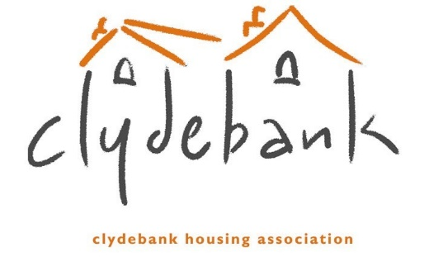
Freedom of Information Request Form

You do not have to use this form but it will make it quicker and easier for us to deal with your request. An online form is available here, if this is more convenient https://clydebank-ha.org.uk/freedom-of-information/foi-requests/. If you choose not to use our form, your request should include the following information: Your full name, address and contact telephone number, details of the specific information you require and any relevant dates.
Withholding Information
Under Freedom of Information legislation, information may be withheld if there is a good reason for doing so. If we withhold information, we will let you know why. If you are unhappy with our decision, or with the way we have dealt with your request, you can ask us to review our decision. If you do not agree with the outcome of the review, you can ask the Scottish Information Commissioner to investigate.
Timescales
We must respond to your request within 20 working days from when we received it (subject to time required for clarifications and payment of any charges), although we may extend the response time for your Environmental Information Regulations request by up to 20 working days in certain circumstances.

Name
Address (including town and postcode)
Please provide your telephone number
Please provide your email address
Please select (by circling) the method by which you would prefer information to be sent to you
Phone / Email / Letter

What information are you requesting?
Any additional information?

