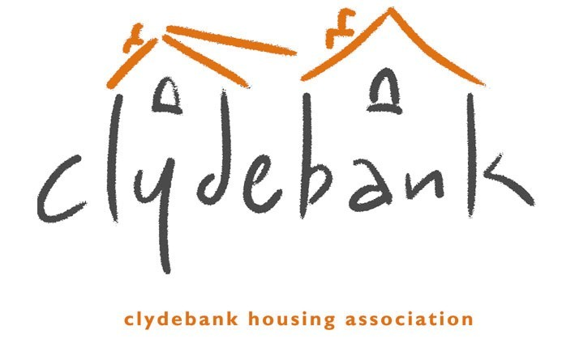
Equal Opportunities Monitoring
APPLICATION NUMBER: __________

We want to ensure that our job opportunities are open to all. The only way we can ensure there is equal opportunity is to monitor applications we receive and compare the profiles of people who apply with those appointed, therefore this form asks you for your ethnic origin, gender, disability and age.

The information you provide in this form is confidential and is not used in the selection process. It will be separated from the rest of the form when we receive it.

Whilst you are invited to complete this form, you are not obliged to do so, either in full or in part.

We have Equality & Diversity and Equality & Diversity in Employment Policies which we commit to review annually.

We are also committed to complying with all current anti-discrimination law, regulations and good practice.

We will seek to ensure that in all our Policies, Procedures and Management decisions there is no discrimination on the grounds of Age, Disability, Gender Reassignment, Marriage, and Civil Partnership, Pregnancy & Maternity, Race, Religion or Belief, Sex, and Sexual Orientation.

We routinely provide information in alternative formats for those who require it, for example, on audio CD, large print or in another language.

As part of our commitment to equal opportunities, we are a recognised Disability Confident Employment accredited by the JobCentre Plus.



A full copy of Clydebank Housing Association’s Equality & Diversity Policies can be obtained from our offices at 77-83 Kilbowie Road, Clydebank G81 1BL. V03.18

1. Gender - Please Tick (✓)
Male |  | Female

2. Disability - Please Tick (✓)
Do you consider yourself to have a disability? By this we mean a condition, which has a long term and substantial effect on your ability to carry out normal day to day activities. |  | Yes |  | No
If yes, is it:
Physical |  | Learning Disability
Mental Ill-Health |  | Other (please specify):
Hearing Impairment
Visual Impairment

3. How would you describe the ethnic origin of your household? Please Tick (✓)
i) WHITE
Scottish |  | Other British
Irish |  | Gypsy/Traveller
Polish |  | Any other white background
ii) Mixed or multiple ethnic background
Mixed or multiple ethnic background
iii) ASIAN, ASIAN SCOTTISH OR ASIAN BRITISH
Indian |  | Pakistani
Bangladeshi |  | Chinese
Any other Asian background
iv) BLACK, BLACK SCOTTISH OR BLACK BRITISH
Caribbean |  | African
Any other black background
v) OTHER ETHNIC BACKGROUND
Arab, Arab Scottish or Arab British |  | Any other group

Where did you see this job advertised?

