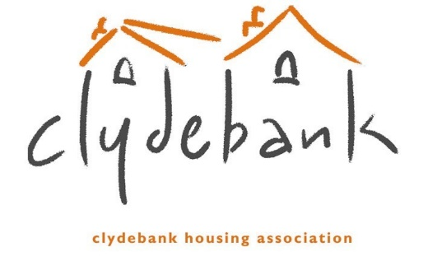

Representation Mandate

This mandate will allow someone to act on your behalf. Please note we also need proof of identity for you both.

Please retain a copy of this mandate and produce this mandate, when acting on behalf of the person being represented.
1. Details of the person being represented
Full Name…………………………………………………………………………………………

Address……………………………………………………………………………………………

Tel No…………………………………… Mobile No…………………………………..

Email……………………………………. DOB…………………………………………

2. Details of the person acting as representative
Full Name…………………………………………………………………………………………

Address……………………………………………………………………………………………

Tel No…………………………………… Mobile No…………………………………..

Email……………………………………. DOB…………………………………………

3. Please specify the area(s) where you want to be represented

Repairs & Maintenance Complaints Payments
Debt Recovery/Arrears Allocations/Rehousing Care/Support Agencies
Other………………………………………………………………………………………

I DO NOT wish amendments to be made to my information by my representative.
4. Please indicate how long you want this representation to last

6 months 12 months 18 months
5. Declaration to be completed by both parties.

We certify that the information given on this mandate is true. We understand that it is necessary for you to confirm our identities and that it may be necessary to contact us for further information to allow this mandate to be processed.
We understand that the information contained in this form may be used to update records held by Clydebank Housing Association.

Signature ……………………………………………………… Date……………………………
Party being represented

Signature ……………………………………………………… Date……………………………
Representative

Guidance Notes for Completion
The form is numbered from 1 to 5 and you MUST complete each section in full.

Section 1 | Enter your details here. Please complete in full.
Section 2 | Enter full details of the person who will be acting as your Representative. Please complete in full.
Section 3 | Without this instruction, we are unable to discuss anything with your Representative. We need to know what areas you wish us to discuss with your Representative. Tick the relevant box for each area. You can tick more than one.  If you DO NOT want your Representative to change information we hold about you, please make sure you tick the relevant box.  You should speak to our staff as to whether you or your Representative want to receive correspondence relating to the areas ticked on this form.
Section 4 | Please indicate how long you want your Representative to act on your behalf.  The maximum duration is for 18 months. At the end of this period, we will automatically notify you and your Representative of the expiry of the mandate with the option to renew.
Section 5 | Please ensure that you and your Representative sign and date this form.

We also require proof of identity. When returning this form, please send proof of identity for you and your representative.

Proof of identity should be forwarded with the completed form:

By handing it into our office or sending it to Clydebank Housing Association Ltd, 77-83 Kilbowie Road, Clydebank G81 1BL

- By email to info@clydebank-ha.org.uk

If there is any part of this form you need assistance with then please contact us on 0141 941 1044.

