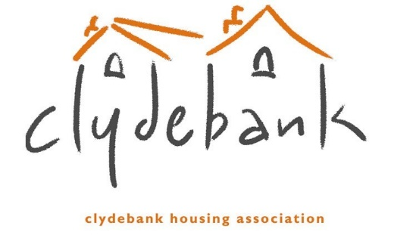
Subject Access Request Form

You should complete this form if you want us to supply you with a copy of any personal data we hold about you. We will endeavour to respond promptly and in any event within one month of receipt of your formal request; or on receipt of any further information we may ask you to provide to enable us to comply with your request.
The information you supply in this form will only be used for the purposes of identifying the personal data you are requesting and responding to your request. You are not obliged to complete this form to make a request, but doing so will make it easier for us to process your request quickly.

1. Name
2. Clydebank Reference numbers - e.g. Account Reference and Household Reference Numbers
3. Email
4. Present Address
5. Postcode *
6. Length of time at current address *
7. If less than 2 years please provide previous address
8. Previous Postcode
9. Telephone number
10. Please specify the information you wish to access (for example Housing Allocation, Tenancy information, Rent Information).
11. What is your relationship to the Association? (Please type/write Yes in the applicable box/es)
- Not Applicable
- Tenant
- Former Tenant
- Factored Owner
- Former Factored Owner
- Other
If other, please specify:

- None
I understand that you may have to make additional checks to verify my identity *. (Please type/write Yes in the box below)
Declaration - I request that you provide me with a copy of the personal information about me which you hold and requested above. I confirm that I am the Data Subject and am not acting on behalf of someone else *. (Please type/write Yes in the box below)
Date of request * (Please type/write the date in the box below)

* Required

Please use this space if need to provide any further information to us.

