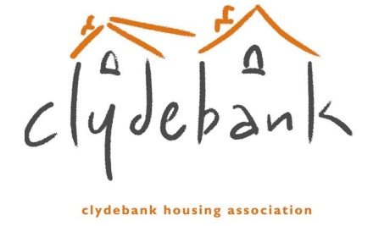
CONSENT TO DISCLOSE PERSONAL INFORMATION
I hereby give consent for Clydebank Housing Association Ltd to disclose my personal data to the following person/organisation:
Name: ___________________________________
Position: ___________________________________
Address: ___________________________________
___________________________________
Tel No: _______________________ Email ________________________
I understand that Clydebank Housing Association Ltd will only disclose information where it is relevant. I also understand that I can withdraw consent at any time by contacting Clydebank Housing Association Ltd.
If relevant, I also give explicit consent to Clydebank Housing Association Ltd to disclose sensitive personal data about me to the above named person as follows:
Consent given (delete as appropriate)
Race or Ethnic Origin Yes/No
Political Opinions Yes/No
Religious or other beliefs Yes/No
Health Yes/No
Trade Union Membership Yes/No
Sex Life or Sexual Orientation Yes No
Signature: ___________________________________ Date: ___________
Name: ___________________________________ Date of Birth: __________
Address: ____________________________________
____________________________________
Post Code ______________________
Tel No: _____________________________ Email __________________________

